Framework
It is pre build foundation that provides basic structure for an application it saves time, reduces errors pronounce reusability, etc.
It is ready made architecture and it needs configurations.

ORIM (Object relational impedance mismatch)
The ORIM are the issues that arise when we try to fit data structures from OOPS into a RDBMS
Major Issues
- Different platforms
- Mapping Issue

Object Relational Mapping
ORM acts as bridge between OOPS and RDB, simplifying the process of working with both the platforms seeing Lessley. ORM does the following things:
- It maps object with the database table
- Provides abstraction
- Automates data persistence
- Reduce boiler plate code

Hibernate
Hibernate framework is a popular open-source framework used in a java application for interacting with RDB, simplifying data persistence.
It acts as object relational mapper which bridges the gap between OOPS and RDBMS
Key features of hibernate are:
- Object oriented persistence
- JPA (Java Persistence API) provider
- Idiomatic persistence: It enables development using natural object-oriented concepts like inheritance, polymorphism and collections.
- Live performance
- Scalable
- Reliable
- Extensible: easy to customize
Hibernate Configuration
In Hibernate Configuration, session factory and session are fundamental components that work together to manage persistence between java application and RDB. This stage establishes the foundation of our hibernate integration with our RDB. It involves defining various ways to configure settings that govern how hibernate operates.
Session Factory
Once the configuration is complete, we build a session factory object using bulidSessionFactory() of the Configuration class. It produces light weight session object and acts session object as a central point for managing DB connection
Session
Session object represents single unit of work with the DB. It provides method for interacting with DB
Dialect
It is used to inform Hibernate/JPA on which type of query it has to perform depending on database.
Generative class
- In Hibernate, entity represented data in tables require unique identifier.
- Generated classes handle the logic behind automatically generating this ID during the object persistence process.
- We can define generative class using @GeneratedValue annotation or <generator> tag

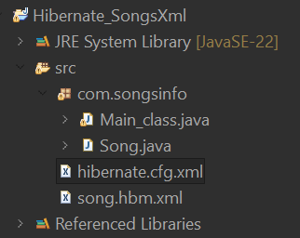
Hibernate_SongsXml
- Song.java (pojo)
- Main_class.java (controller)
- Hibernate.cfg.xml (jdbc connection)
- Song.hbm.xml (mapping)

Hibernate.cfg.xml (connection)
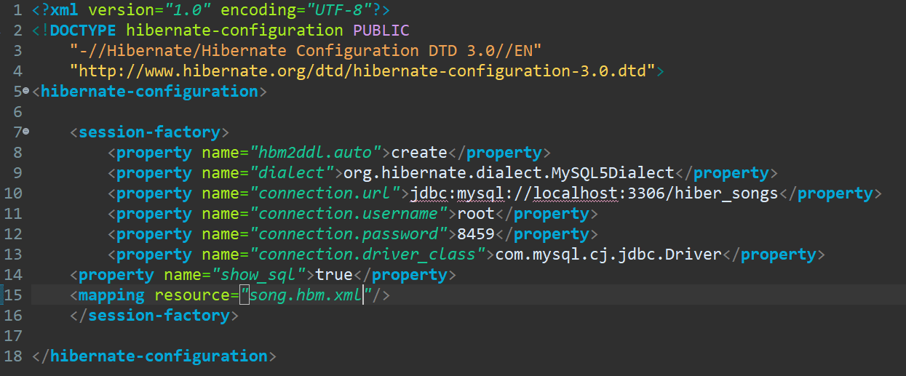

Song.hbm.xml (mapping)
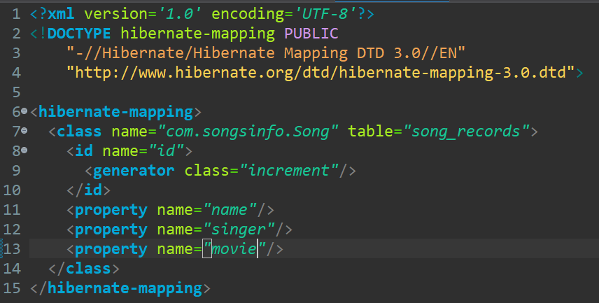
Main_class.java (controller class)
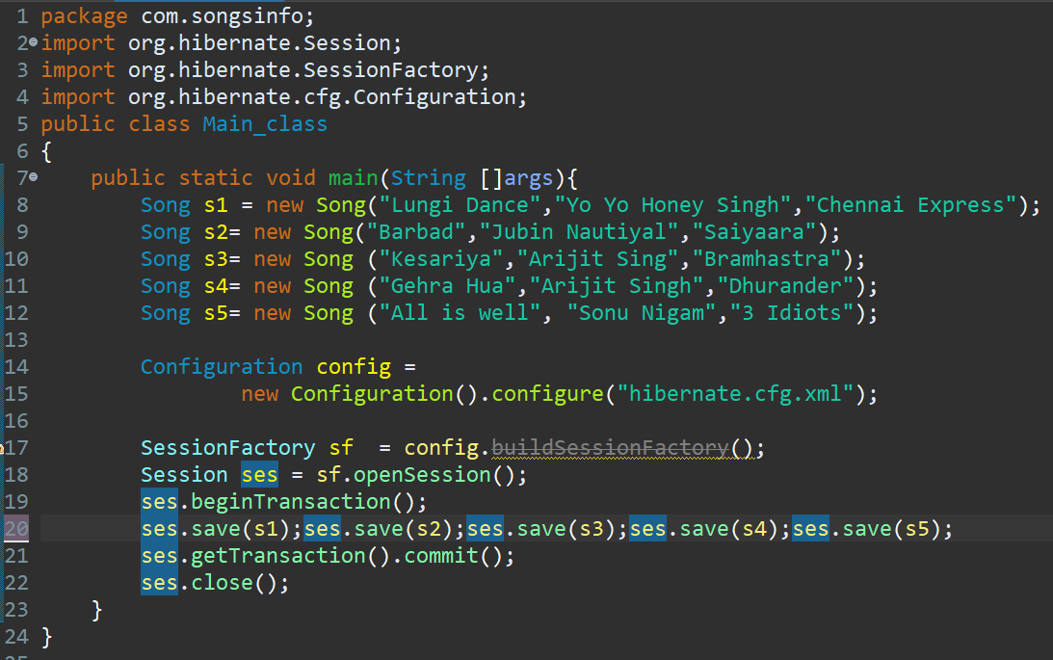
OUTPUT
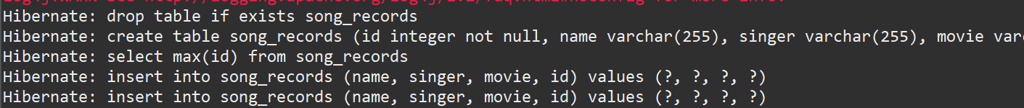
Hibernate

Maven Project
- Annotations
- Class (2)
- Config.xml

Normal Project
- Jar files
- Class (2)
- Config.xml
- Mapping.xml

Maven
Maven is popular tool for managing software projects, those build with Java.
- It is an open-source build automation tool developed by apache software foundation.
- It streams lines project life cycle like building, testing, packaging, deployment.
- It was founded on concept of POM (Project Object Model), a central file containing project configuration key benefit of maven are it enforces consistent build processes across projects, simplifying collaborations.
- Dependency management
It automatically downloads and manages external libraries that our project relies on.

Pom.xml
It is xml file specifying project details, dependencies, configurations, plugins and more.
Plugins
Plugins are reusable components that extends maven functionalities for special tasks.
Annotations
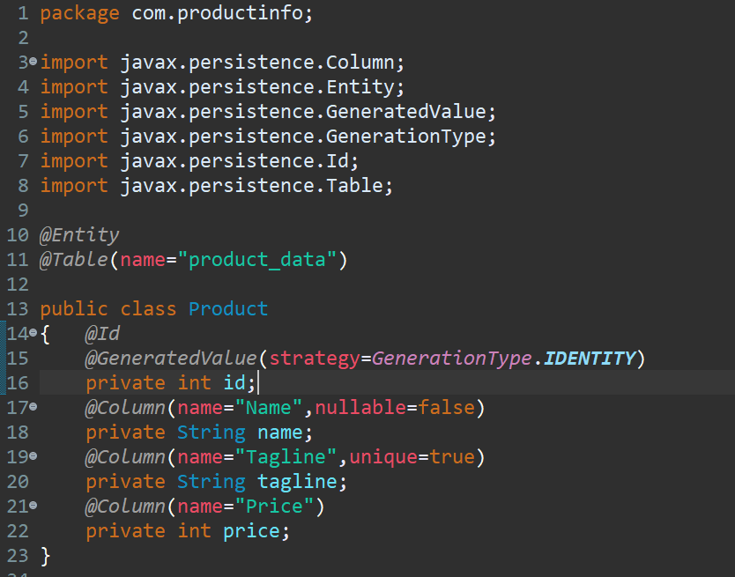
Annotations in java are form of meta data that provides the data about the program but are the not part of the program itself. They have no direct effect on the operation of the code. We declare annotation with ‘@’ it can be used with class methods and interface.
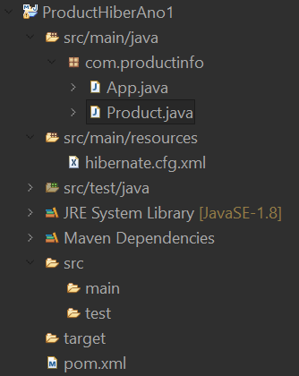
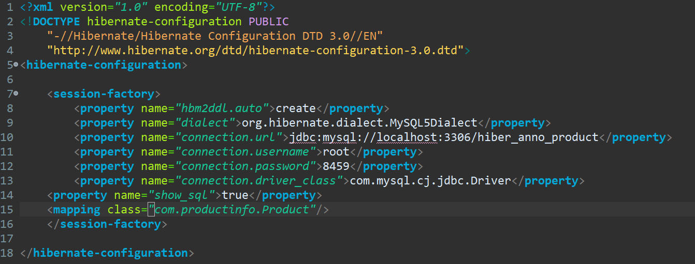
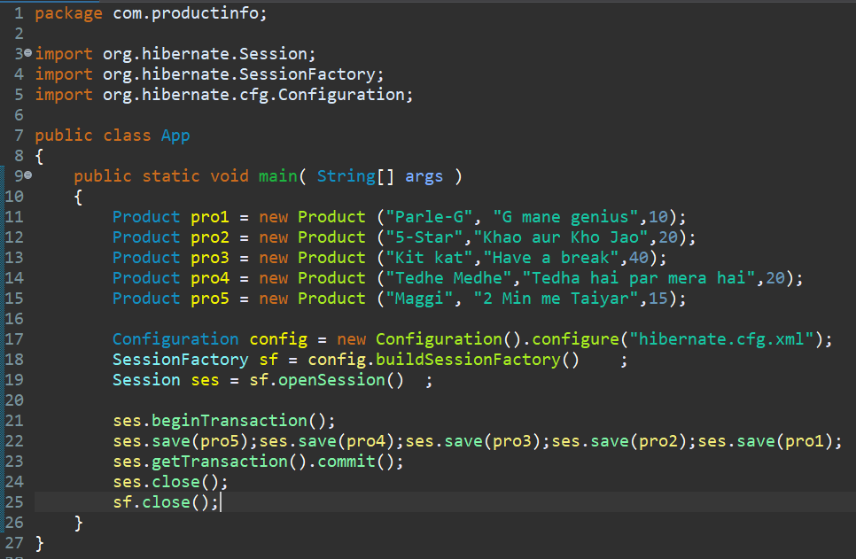
FOR UPDATE
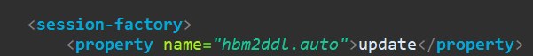
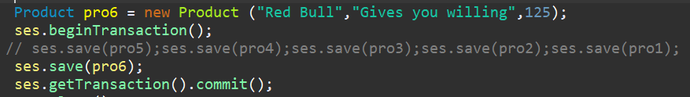

STEP BY STEP FLOW
- Create a Maven Project
- Catalog-Internal Group id:
- Keep group id and package same
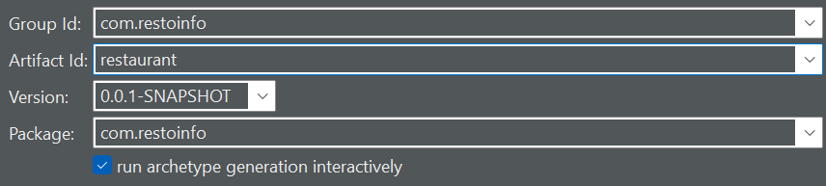
- Y in terminal
- Add Dependencies in pom file
- Create new folder in src/main -> resources
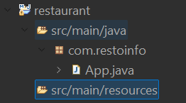
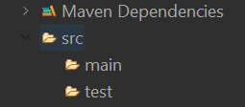

- Create configuration (hibernate.cfg.xml) file in src/main/resources
- Copy the jar dependencies in a pom.xml file
- Create POJO class in com.restoinfo package (don’t forget to add annotaions)
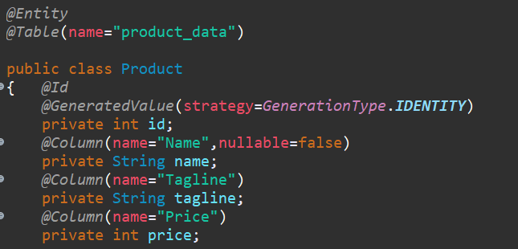
- Define DB url and mapping class in configuration file (hibernate.cfg.xml)
- Create 5 objects and then
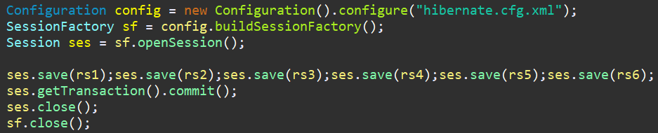

JPA (Java persistence API)
It is a specification that simplifies RDB being accessed by java application and it bridges the gap between java objects and RDB. It takes care of persistence logic like creating, updating, deleting the data in the DB.
Hibernate is an implementation of a JPA.
EntityManagerFactory- It is responsible for providing instances of EntityManager which are objects we use to interact with our persistence object. It also manages the life cycle of EntityManager object.
EntityManager – It is the core interface to interact with JPA to manage all persistence operation. It provides methods for CURD operations on our entity as well as functionality for querying and managing persistence context.
STEP BY STEP
- Create a Maven Project
- Same (2,3,4,5) step like before
- Create META-INF in Java resources (no spelling mistakes)
- Create persistence.xml in META-INF (no spelling mistakes)
- Change DB details & package name in persistence.xml file
- Create a POJO with annotations same like pervious one
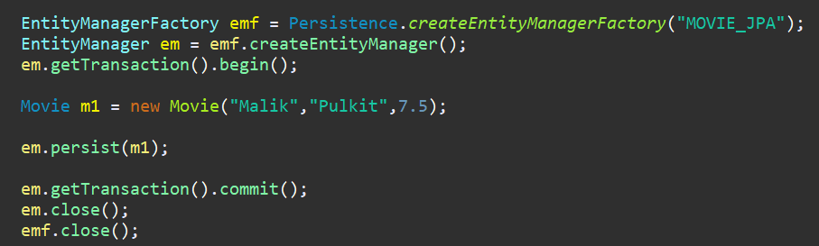

Update when you need to update
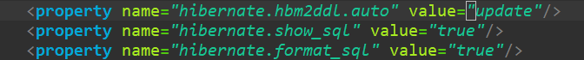
CURD operations
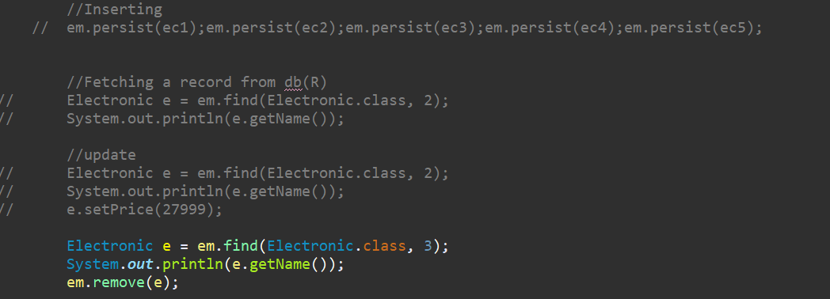

1.MovieAnno JPA

Annotations (IMP for Interviews)
JPA/Hibernate Annotations
- @Entity: It is used to mark a java class as a persistence entity meaning its objects will be stored in a database table.
- @Table: It is used to specify the name for Database table.
@Table(name=”product_data”)
- @Id: It specifies the field as a primary key (majorly id)
- @Genereated Value: It is used to specify how id value is generated.
- @Column: It is used to specify the name of database column representing the corresponding field.
- @Embedded: It is used to embed has a relationship
- @JoinColumn
- @OneToOne

OneToOne
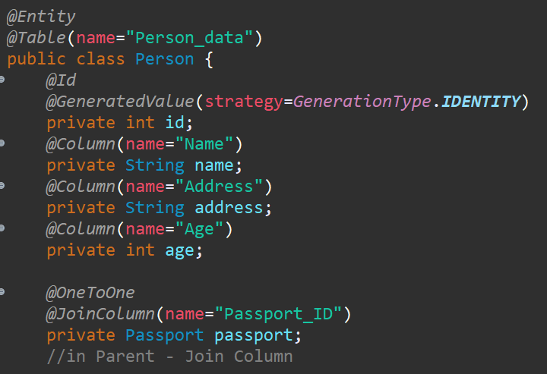
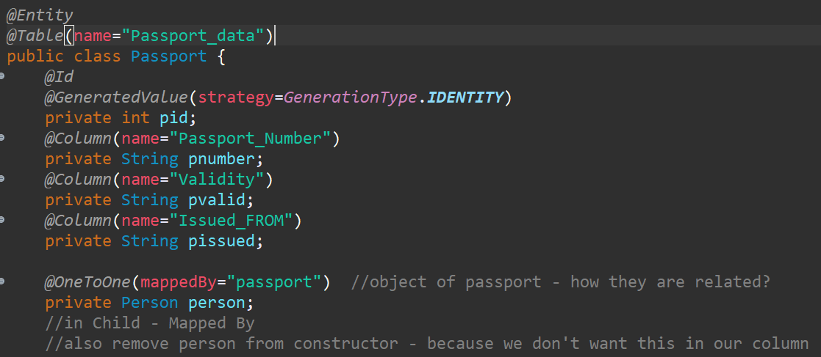
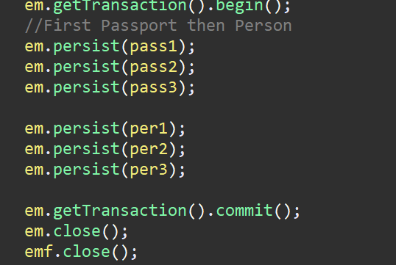

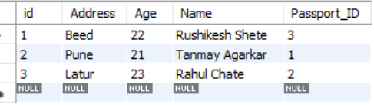

Cascading
Cascading in JPA: It is powerful feature in Hibernate/JPA that simplifies managing relationships between entities. It allows us to automatically propagate operations such as save, update or delete, etc, from a parent entity to which related child entity. It reduces boiler plate code by eliminating the need to manually persist, update or delete related entities
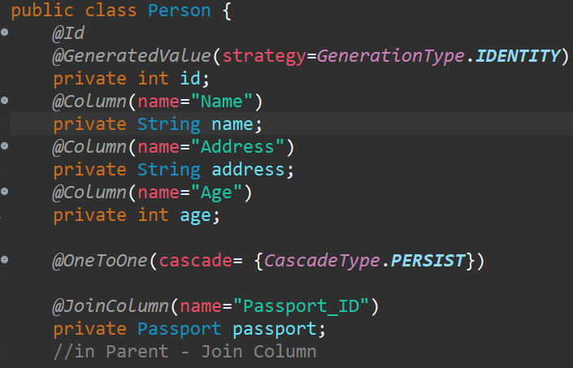
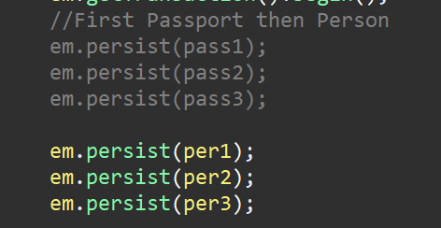

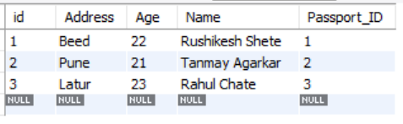

Maps ID
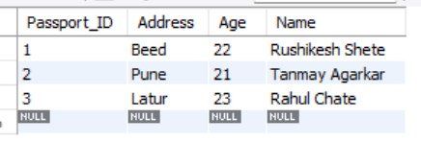
In this table ID column of person is removed and it is replaced by Passport_id
For this only two changes
- comment out auto increment of parent
- add @MapsId in the parent class above child’s variable
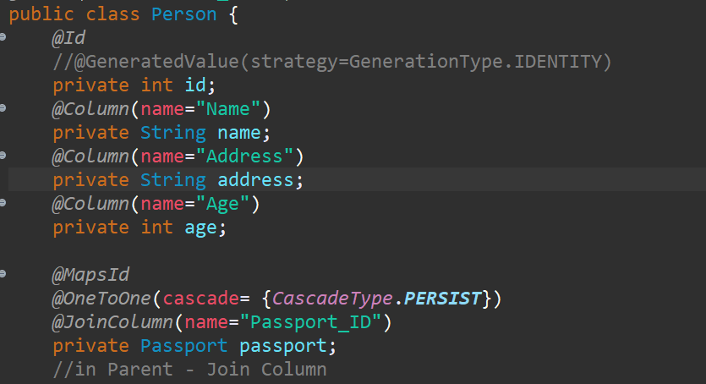

CompanyInformationJPA
Many to One
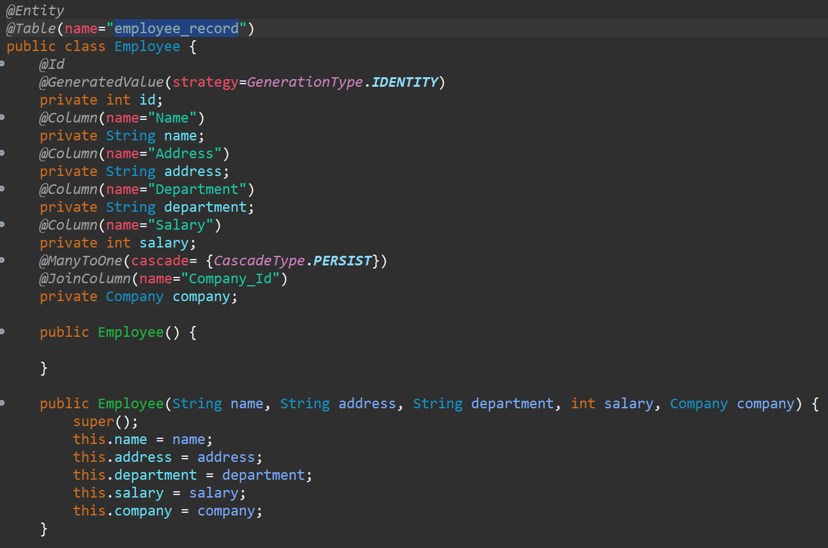
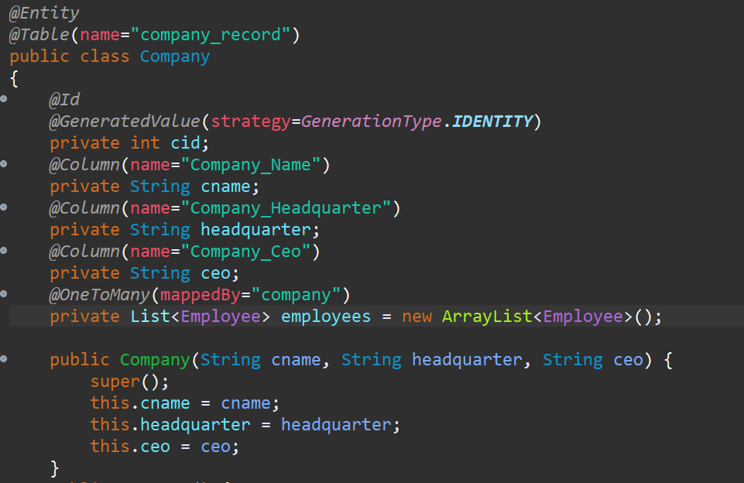

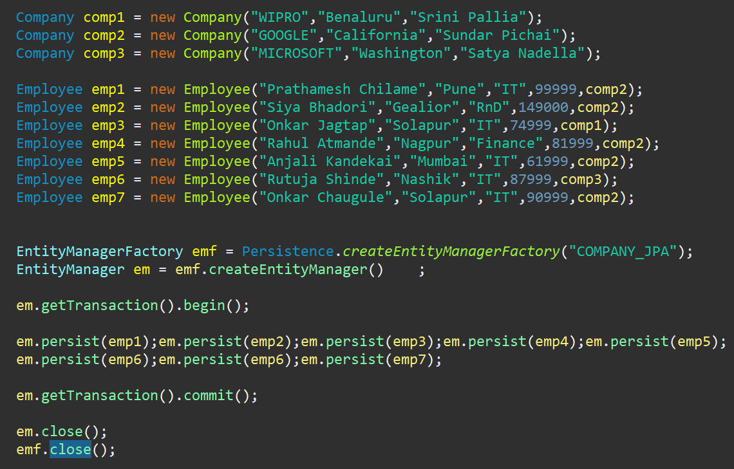

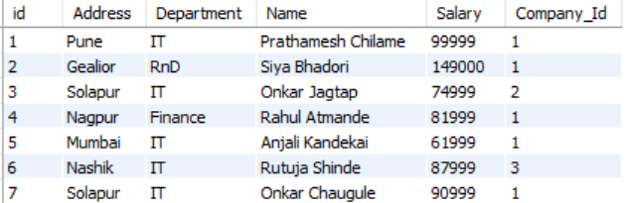

MoviesDataJPA
Parent-Movie
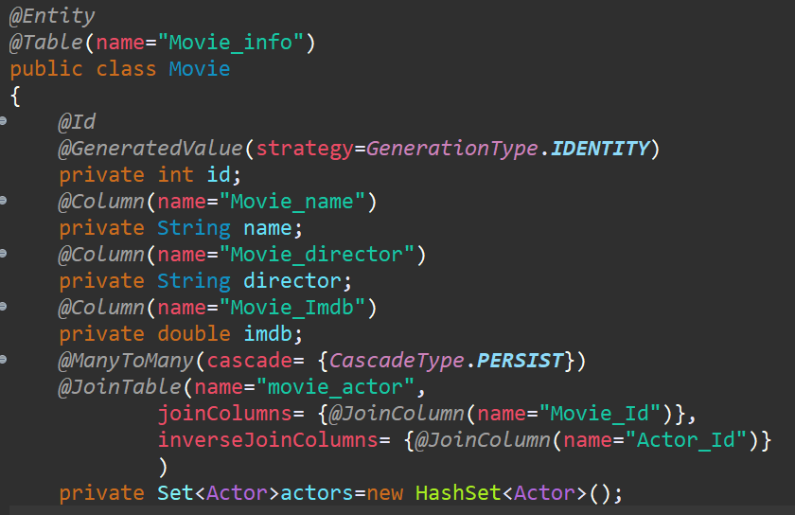
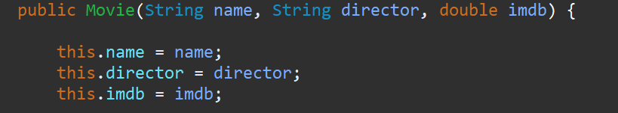
Child-Actor
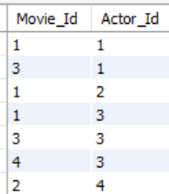
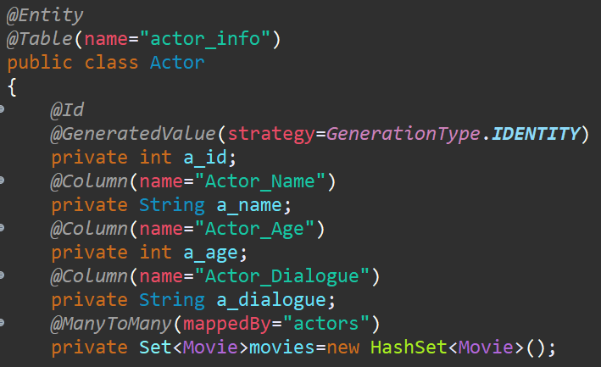
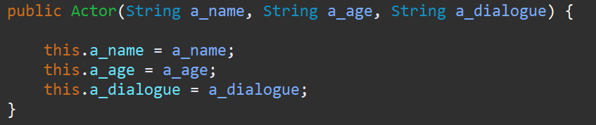

JPQL (Java Persistence Query Language)

Java Persistence Query Language:
JPQL is an object-oriented query language specially designed for JPA. Unlike SQL, which operates directly on DB tables JPQL interacts with our Entity class which represents our data model in java. This makes JPQL queries more readable, maintainable and less prone to errors comparing raw SQL.

FetchType in JPA (Interview Question)
It decides how related entities are fetched/loaded from the database. It is of two types 1. FetchType.EAGER 2. FetchType.LAZY
OneToOne => FetchType.EAGER
ManyToOne=> FetchType. EAGER
OneToMany=>FetchType.LAZY
ManyToMany=> FetchType.LAZY

- FetchType.EAGER
Related entities are loaded with main entity immediately
- FetchType.LAZY
Related entities are loaded when it is accessed.

N+1 Problem
Solution for N+1 problem is Fetch-Join

Cache in JPA / Hibernate
It is an optimization mechanism the helps reduce the number of database queries by storing frequently accessed entities or query results in memory.
JPA / Hibernate
- Provides First level cache (L1 Cache)
- Supports Second level cache

- First Level Cache (L1 Cache)
Scope: Per EntityManger / Session.scope
It is always enabled by default
When you fetch the entity using EntityManger / Session, it is stored in the first level cache. Now if you fetch the same entity again within the same EntityManger / Session, JPA will return it from the cache memory meaning no SQL query will be fired.

- Second Level Cache (L2 Cache)
Scope: Per EntityManagerFactory / SessionFactory
It is not enabled by default or directly.
You need to provider EH cache provider Hezal cast, Infiny Spam, etc to work second level cache.
It is useful when you want to cache entities across sessions, entity managers improving performance in multi user applications.

IMP Points
Annotation
Cascading
FetchType
JoinTable
N+1 Problem

